How to Conduct A Blue Tarp Waste Audit

Created by Katrina Venhuizen, Environmental Educator at ecomaine – venhuizen@ecomaine.org

Number of participants: 1-100, as long as space allows
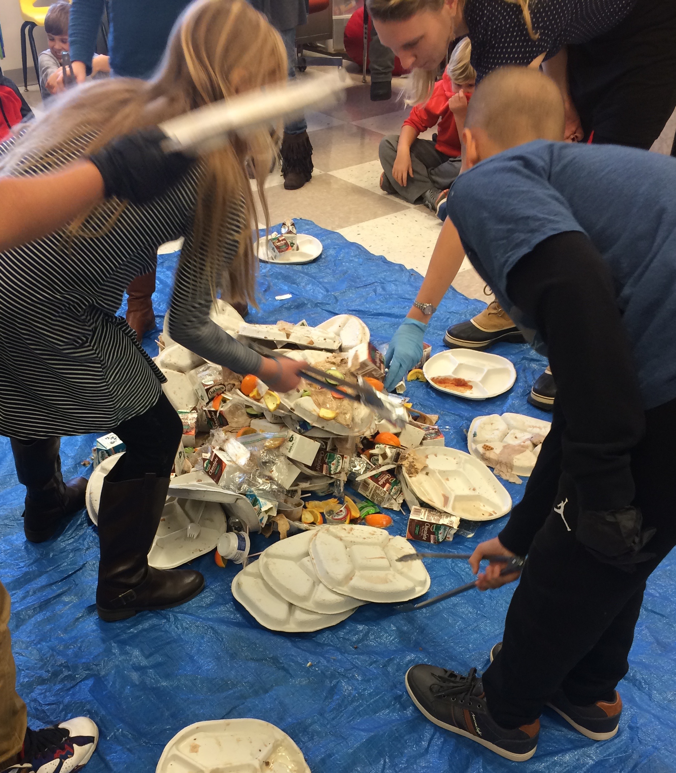
Length of time needed: 20-60 minutes depending on depth reached

Materials needed: large tongs, gloves, giant tarp, trash (never use bathroom trash), scale, large Tupperware-type containers (for ease of weighing after all is sorted), whiteboard and markers or other writing surface for graphing

Goal of program: to show participants how much of their trash can be placed in other bins for further use. An eye-opening experience for all!

Procedure:
- Gather students/participants and sit them around tarp. Explain that today, they will help you go through the trash created by their school/business.

- Weigh trash and talk about the waste hierarchy. What could be in this trash bag? Discuss what they throw away every day. Plot the weight of the trash on a graph labeled with pounds on the left axis and “trash” “recyclable” “compost” and “reusable” along the bottom.

- Dump trash out on the tarp and call a few students up at a time to help sort. Explain which pile is in which corner and hand out gloves and tongs.

- Help students/participants sort through trash, putting correct materials in correct corners. If all want to participate, cycle them through, helping a few minutes at a time. Have them share gloves to cut down on trash created. Do not add gloves to their trash pile as it will slightly affect weighing at the end.

- Once all materials are sorted, weight “compost” “reuse” and “recycle” and “trash”. Graph their numbers on the board and do some math if time. Compare “trash” amount to first weight and marvel at the difference.
- Continue with waste hierarchy discussion on what’s the best practice to do with “that thing in your hand.” Can items be reduced, reused, recycled or composted before being put in the trashcan?

- Challenge students to come up with ways to reduce waste production in their own lives.

Extensions:
- Math is used in this lesson by subtracting weights from original measurement. You could go further with it by asking the question: “Based on the numbers we discovered in the Blue Tarp Audit today, how much trash would we have thrown out each year vs how much could we have saved assuming every day’s trash is the exact same.”
- Writing could be introduced using prompts such as “What did you learn from the Blue Trash Audit today?” or “From what you learned during the Blue Trash Audit, what could I do to reduce the amount I throw away?”
- Art could be any number of projects, including having students make signs to put around disposal areas to illustrate what can go in each bin.

