**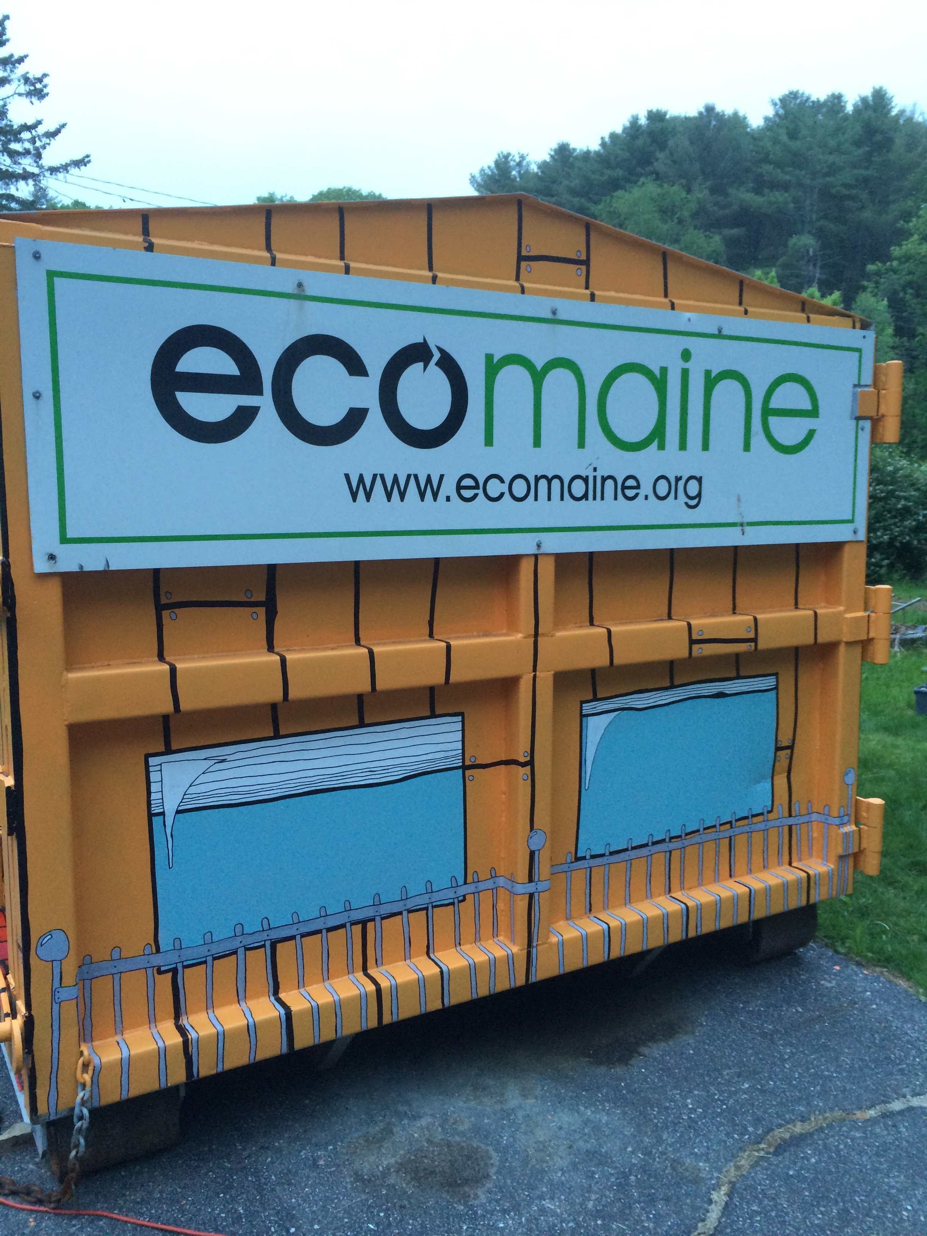Recycling is a**

Deadline: Friday, May 22, 2017

venhuizen@ecomaine.org

**ecomaine_2Cno tag.jpgWork of Art**

**Short Side B**



Indentation for trailer hitch

**Short Side A**