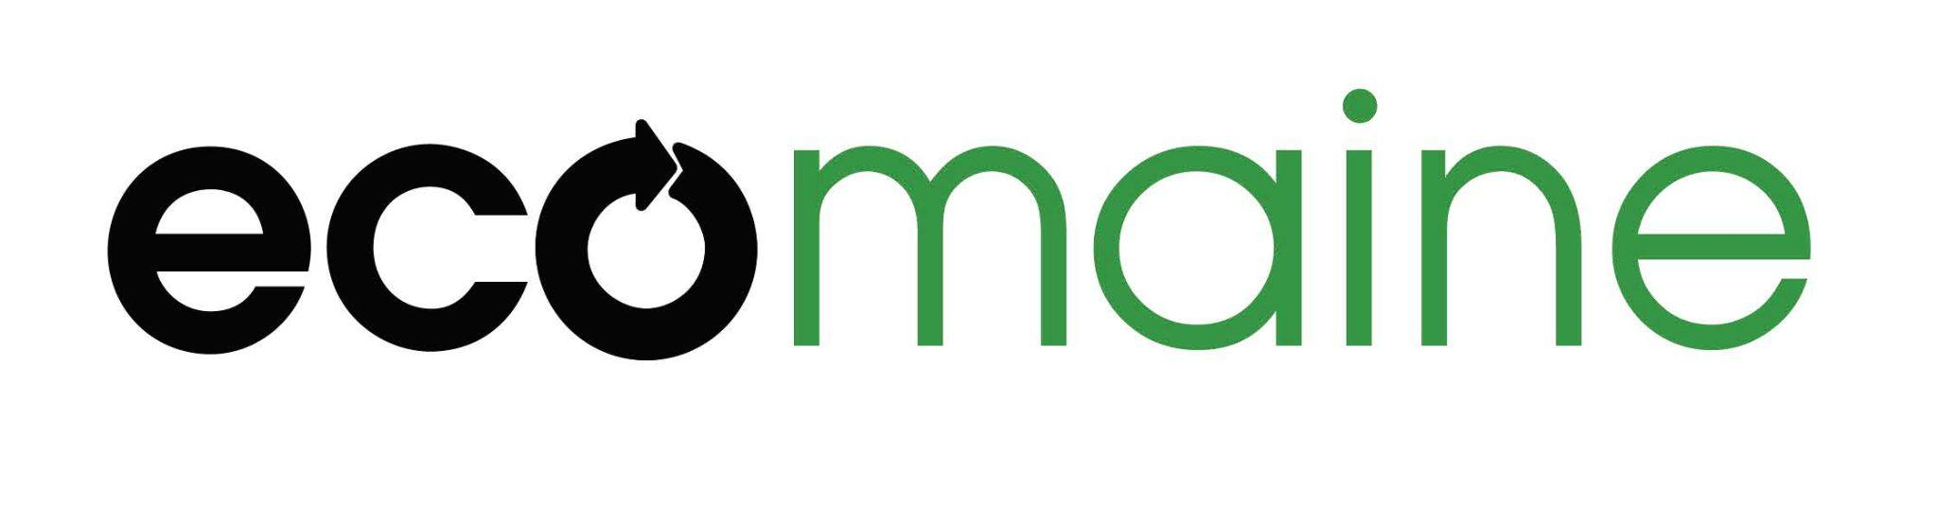
School Waste Diversion Grant Guidelines
ecomaine’s School Waste Diversion Grants provide project-specific funds to schools and educational organizations to support solid waste management. Projects should involve students and educators in diverting waste from landfills by increasing recycling, reuse, composting, or other waste diversion strategies.

- Grant eligibility/qualifications
  - Must be a school that serves students that live in a municipality served by or affiliated with ecomaine. (Visit ecomaine.org for full list of communities; if you have questions about eligibility, contact info@ecomaine.org.)
  - To receive full funding, the school must agree to participate in two progress reports to ecomaine: one in-person site visit and review conducted by ecomaine staff in early spring 2026; and a written final report upon the completion of the project (submitted no later than May 20, 2026).
  - School must be willing to freely share their program and results for replication and education purposes.
- Grant money available
  - ecomaine has dedicated $30,000 to school grants in this funding cycle.
  - Schools may apply for a grant in any amount up to $5,000.
  - Money awarded by ecomaine must be spent in accordance with the applicant's submission to ecomaine.
  - Grant monies will be awarded to schools, not individuals.
  - Grant monies will be disbursed:
    - 80% upon signature of initial grant agreement.
    - 20% upon completion of the final project report.

- Grant Application
  - Applications are due by October 15th; late applications will not be considered.
  - Grant applications must be approved by the school or organizational leadership (principal, superintendent, president, or executive director)
  - The application must be submitted via ecomaine’s application form, which can be requested here: https://www.ecomaine.org/tours-and-educational-outreach/grants/
- Notification
  - All submitters who have provided valid contact information will be notified of whether their application was successful no later than December 1, 2026.
  - ecomaine may contact submitters with questions about their submission. These questions do not constitute notification that funds have been awarded.
  - Recipients of grants must respond to ecomaine’s notification of funding and return their signed grant agreement in a timely manner to be eligible for funds.

*Final reports to be completed no later than May 20, 2026. Failing to complete a final report may affect future grant consideration.

Examples of Eligible and Ineligible Projects
The following examples are provided to help guide you in determining whether your proposed project is eligible for funding. It does not constitute a comprehensive list of eligible projects and we encourage creative ideas and solutions. If you have further questions, please contact info@ecomaine.org.

Eligible Projects
Projects that reduce waste sent to landfill through reduction, reuse, recycling, or composting. Examples:
    - School-Wide Composting Program: Launching a composting initiative in the cafeteria and classrooms, including compost bins, student training, and signage.
    - Reusable Cafeteria Ware Initiative: Replacing disposable plates, cups, and utensils with reusable items to reduce waste during school meals.
    - Recycling Bin Expansion and Education Campaign: Adding recycling bins in key areas and creating student-led videos or posters to teach proper recycling habits.
Ineligible Projects
Projects that do not focus on waste diversion, are one-time events, or lack measurable outcomes. Examples:
    - School Garden without Composting: A vegetable or flower garden project that doesn’t include food waste composting or waste diversion education.
    - Beautification or Landscaping Projects: Painting murals, planting trees, or other aesthetic improvements not tied directly to waste reduction.
    - Funding for Subscription Service: Projects focused solely on curbside compost subscriptions will not be considered.
Application Questions
This list of questions is for reference, to assist you with preparing your application. Applications must be submitted through our online form to be considered.
Project Contact Information
- Name, title and contact information for the primary point of contact for the project
School/Organization Information
- Name of School / Organization
- Name of ecomaine Community
- Physical Address
- Name and email of school/organization administrator approving funding
- Has your school ever received a School Waste Diversion Grant from ecomaine? If so, in what year?
Proposal Narrative
- Describe your proposed project. Include:
  - a description of the problem or need you wish to address and how this project will contribute to a solution
  - the project activities and an approximate timeline (please note that initial funds will be available in December, and final reports are due May 20, 2026) Recommended: 250-500 words.
- How might this project be replicated or sustained after the conclusion of the initial grant term? Recommended: 150-250 words.
- How does this project integrate with your curriculum, or your organization's work as a whole? Recommended: 150-250 words.
- How will students play an active role in this project, and what do you expect them to learn from this experience? Recommended: 150-250 words.
- How will you evaluate the success of this project? Recommended: 100-150 words.
- Total amount of grant funding requested (Up to $5,000)
- Project Budget
Timeline and Reporting Confirmation
- Do you agree to participate in a timely mid-year review (February/March 2026) and to submit a final report (May 20, 2026), and to provide any additional updates to ecomaine regarding personnel changes or other barriers to completion as necessary?

